Children of Hope Format (ACTS)
ADORATION: We show Jesus that we love and respect the awesome gift of His true presence in the Eucharist by kneeling, prostrating, praying, singing, and listening in silence.
CONTRITION: We prostrate in silence to examine our conscience, acknowledge the abundance of Jesus’ mercy, and pray for the pour souls in purgatory
THANKSGIVING: We express gratitude for our many blessings.
SUPPLICATION: We prostrate and humble ourselves as we offer intentions silently and then take turns sharing our petitions aloud.
Suggestions
- Invoke the Holy Spirit for guidance.
- Embrace moments of silence mixed with a few words from Holy Scripture or meditations to help the adorers listen to Jesus in the silence of their hearts.
- Include a decade of the rosary in honor of Jesus’ Blessed Mother and our role model for adoring her Son, Jesus.
Observations
- Keep in mind this is a process, children will take away a different experience each time.
- The amount of time spent in silence will vary according to the ages of the youth attending.
- The more time that our youth spend developing a personal relationship with Jesus the more their souls reflect His love.

“If I can give you any advice, I beg you to grow closer to the Eucharist and to Jesus…We must pray to Jesus to give us that tenderness of the Eucharist.” Mother Teresa
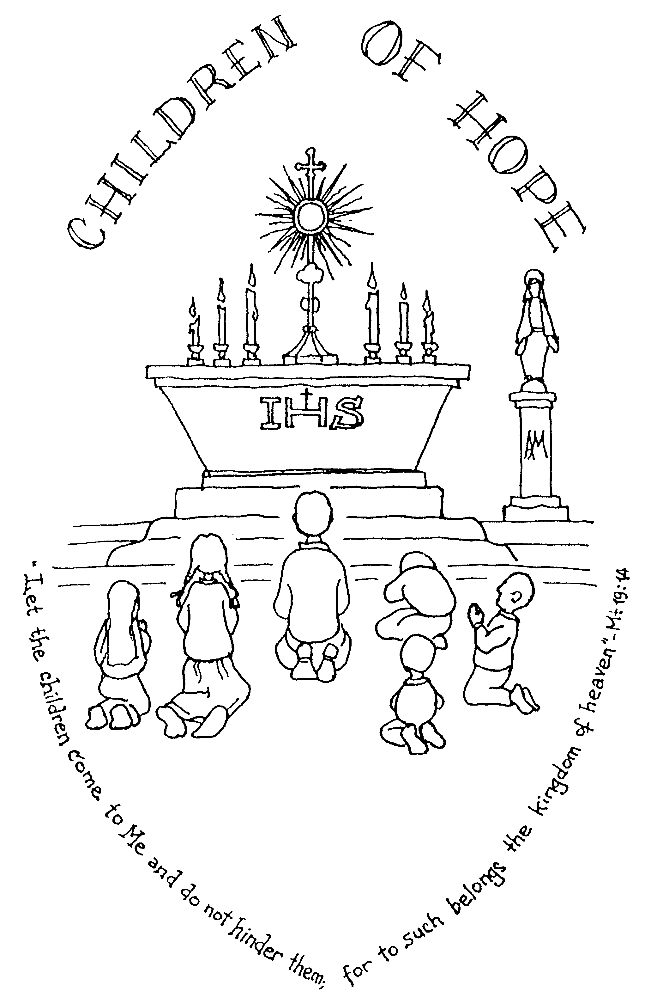

Children of Hope is dedicated
to leading children into the mystery of the Real Presence of
Jesus Christ in the Eucharist.

Eucharistic Adoration

Eucharistic adoration is the act of worshipping God as He is truly present in the consecrated Host.

“In the most Blessed Sacrament of the Eucharist the body and blood together with soul and divinity of our Lord Jesus Christ and, therefore, the whole Christ is truly, really and substantially contained.”
Catechism of the Catholic Church

"Our communal worship at Mass must be together with our personal worship of Jesus in Eucharistic Adoration in order that our love may be complete," Pope John Paul II

“Of all devotions, that of adoring Jesus in the Blessed Sacrament is the greatest after the sacraments, the one dearest to God and the one most helpful to us.”
St. Alphonsus Liguori

Children and Adoration

“I would like young people to gather around the Eucharist as the vital source which nourishes their faith and enthusiasm… bring to your encounter with Jesus, hidden in the Eucharist, all the enthusiasm of your age, all your hopes, all your desire to love.” Pope John Paul II

In our noisy world, Eucharistic Adoration enables the youth to discover the silent, loving presence of Jesus in the Eucharist. Before Our Lady appeared to Lucia, Jacinta and Francisco at Fatima, an angel, holding a chalice and the Eucharist, visited the three children. The angel placed the Body and Blood of Our Lord suspended in air and then knelt down by the children. The angel showed the children how to prostrate or bow before Jesus, humbling themselves before the amazing and true presence of Our Lord in the Eucharist.

Children of Hope

“When children become friends with Jesus, by spending time with Him, do they not become living signs of faith in Jesus’ real presence in the Eucharist?” Father Antoine Thomas

Children of Hope was founded in France by Father Antoine Thomas of the Community of St. John at the request of a mother to lead a holy hour for children. Since then, Children of Hope Eucharistic Adoration has spread throughout the US and the world. Pope John Paul II gave his Apostolic Blessing to this program as it responded to his own appeal that the youth be exposed to Our Lord in the Eucharist on a regular basis. Catholic schools are establishing weekly school days devoted to Eucharistic adoration.

“I urge priests, religious and lay people to continue and redouble their efforts to teach the younger generations the meaning and value of Eucharistic adoration and devotion.” Pope John Paul II

Materials and Resources

childrenofhope.org
therealpresence.org
“Behold the Lamb of God”, music CD
Praying In The Presence of Our Lord
The Bible
Prayer booklets
Decade Rosaries
CD Player/ Guitar
Videos- Children’s Adoration in the Third Millineum When Children Adore and
The Mass Unveiled for Children

